**Case Study 1: Setting Up a Personal Linux Server**

**STEP 1:** Setting up and managing a basic Linux server for hosting files, websites, and services

Setting up an Ubuntu Distribution in the Virtual Machine and Installing the appropriate version for the OS.

**STEP 2:** Perform Initial Configuration- Updating the System

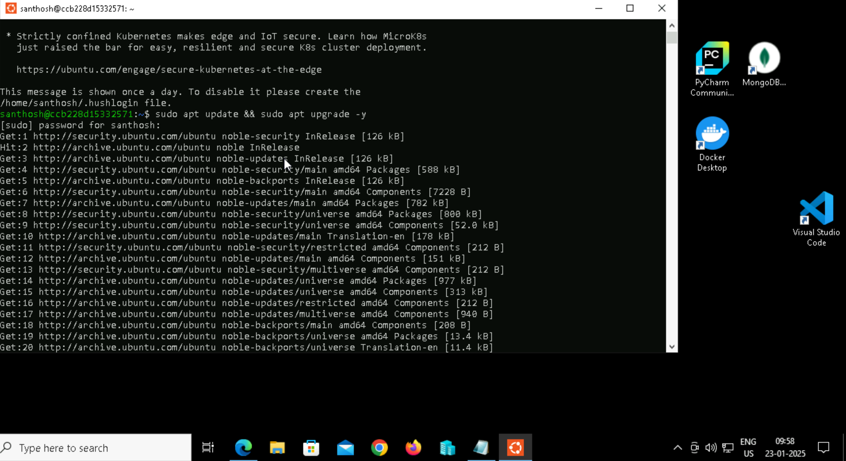

**STEP 3:** Setting up a Static IP Address

Directing to the network configuration file in the path using sudo nano /etc/netplan/01-netcfg.yaml

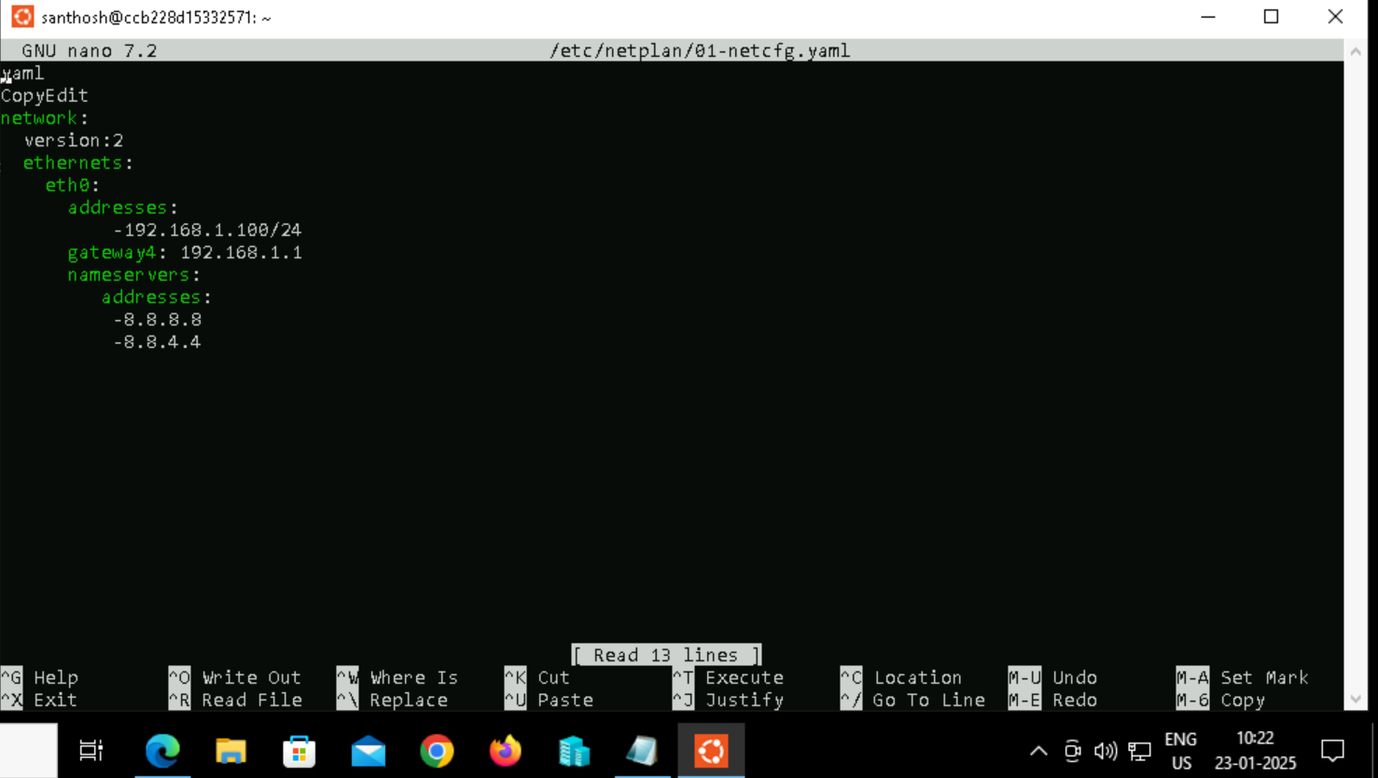

Applying the changes using